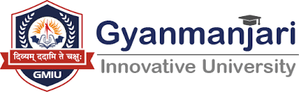

Gyanmanjari Institute of Management Studies Bhavnagar

Report on
Industrial Visit ___________________________________________
Date: | 19/08/2026
Time: | 10:00 AM to 12:00 PM
Venue: | FF 6

No. of Student | 29
Department | Management
Semester | MBA 1
Faculty Co-Ordinator | Prof. Tulsi Kondhiya

Objective:
The objective of the Industrial Visit Program conducted as a TPA (Training and Placement Activity) is to provide students with practical exposure to industrial operations and workplace practices. The visit aims to bridge the gap between theoretical knowledge acquired in the classroom and its practical application in real-world industries. It helps students understand organizational structures, production processes, modern technologies, safety practices, quality standards, and professional work culture. The program also encourages students to interact with industry professionals, gain insights into career opportunities, and develop awareness of the skills and competencies required for successful employment.

About Activities:
The Industrial Visit Program is an experiential learning activity organized under TPA to familiarize students with the functioning of industries and corporate organizations. During the visit, students observe various industrial processes, departments, equipment, technologies, and operational practices. Industry representatives and professionals interact with the students and explain the workflow, technical processes, safety measures, quality control systems, and employment opportunities available in the sector. The activity provides students with valuable practical knowledge, enhances their understanding of industry expectations, and motivates them to develop relevant technical and professional skills for their future careers. It also strengthens the interaction between educational institutions and industries, creating opportunities for meaningful industry-academia collaboration.

Photographs:
